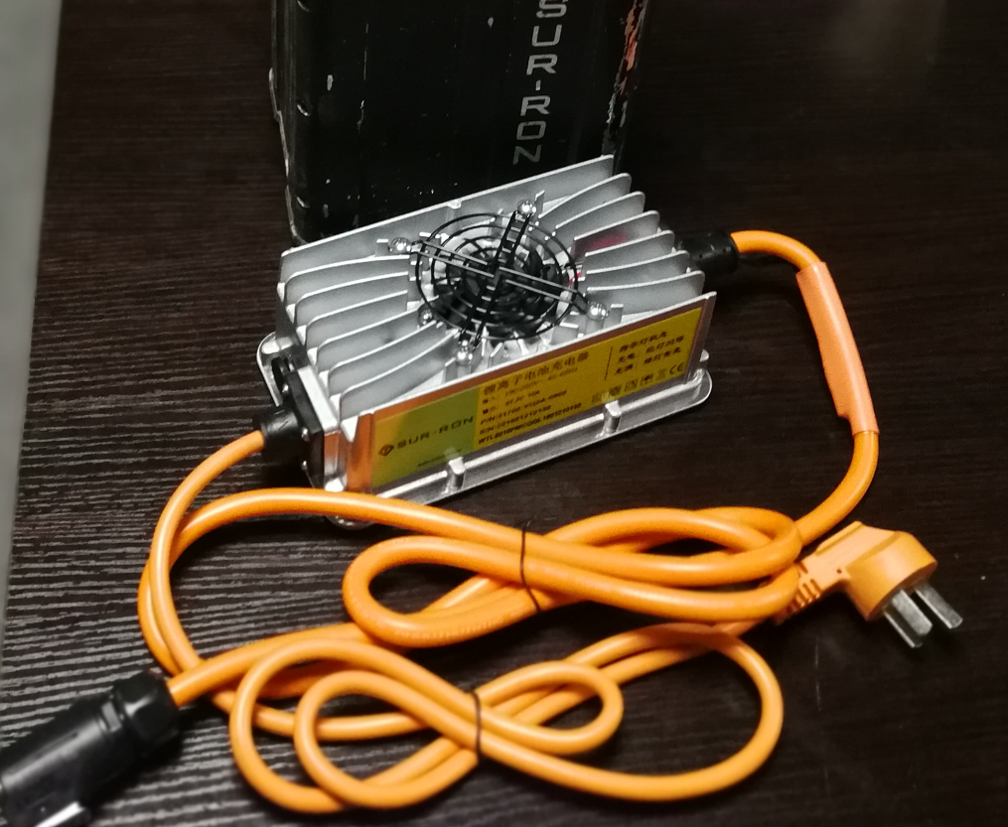
CHARGER ACTIVATION INSTRUCTIONS
Step 1: Connect the charger with the battery charging connection. And then, insert the charger plug into the socket of the power grid. This moment, the red and green indicators of the charger will alternately blink.
Step 2: Plug-out and Plug-in the charger plug (which is connected with the socket of the power grid) for one time. This moment, the red indicator of the charger will blink fast (0.5 second per time). The blink time will last to 20 seconds.
Step 3: After 20 seconds blink, the red indicator will be constant light for 10 seconds. During the 10 seconds, plug-out and plug-in the charger plug (which is connected with the socket of the power grid) for one time.
Step 4: After Step 3, the “Forced Charging” function of the charger will be turned on. Then, the charger will work normally.

Remarks:
- In Step 2, during the red indicator’s 20 seconds fast blink, please do not plug-out and plug-in the charger’s plug. Otherwise, you need to start the procedure again from step 1.
- In Step 3, the action to plug-out and plug-in the charger’s plug need to be finished during the 10 seconds, when the red indicator is constant light. Otherwise, you need to start the procedure again from Step 1.

